- Now after creating a bean shell, will just go to Options and then select Log viewer.
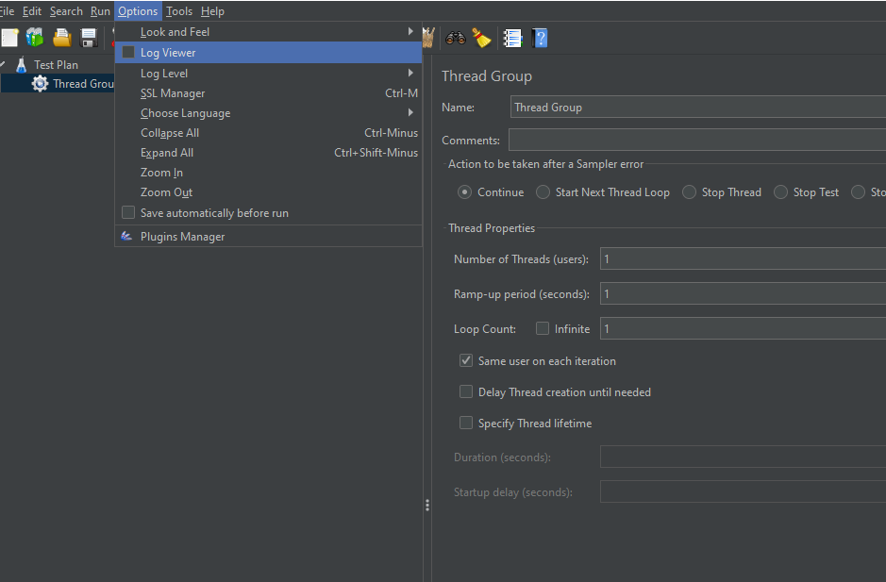
- After selecting that check box will get Log viewer in bottom of this screen where we can get all logs.
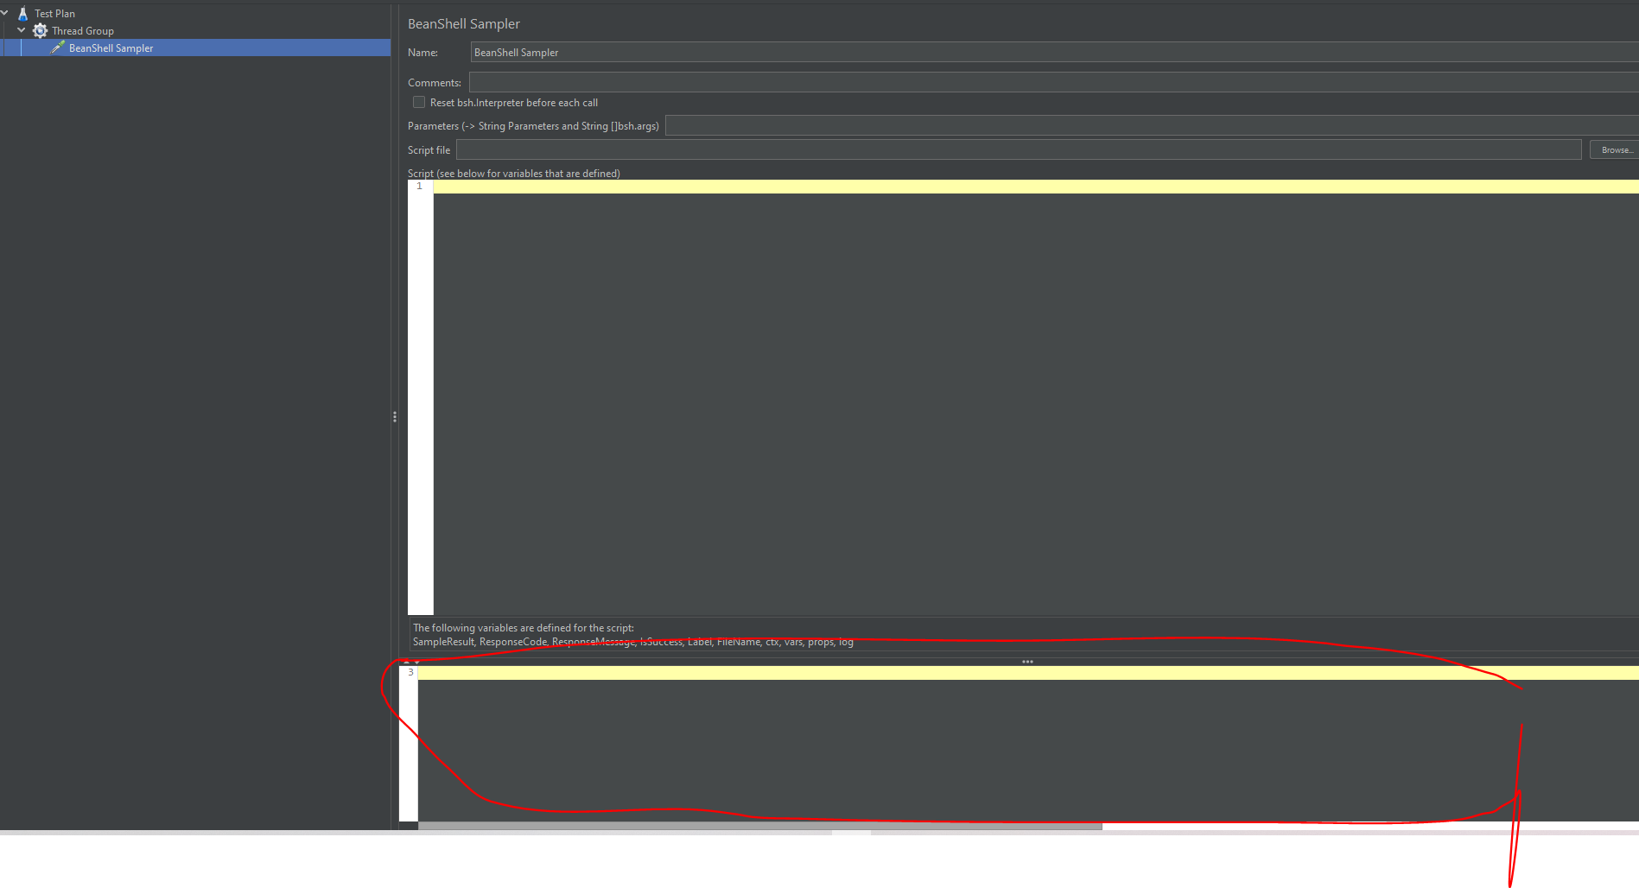
- Java Script programme and its results are below.
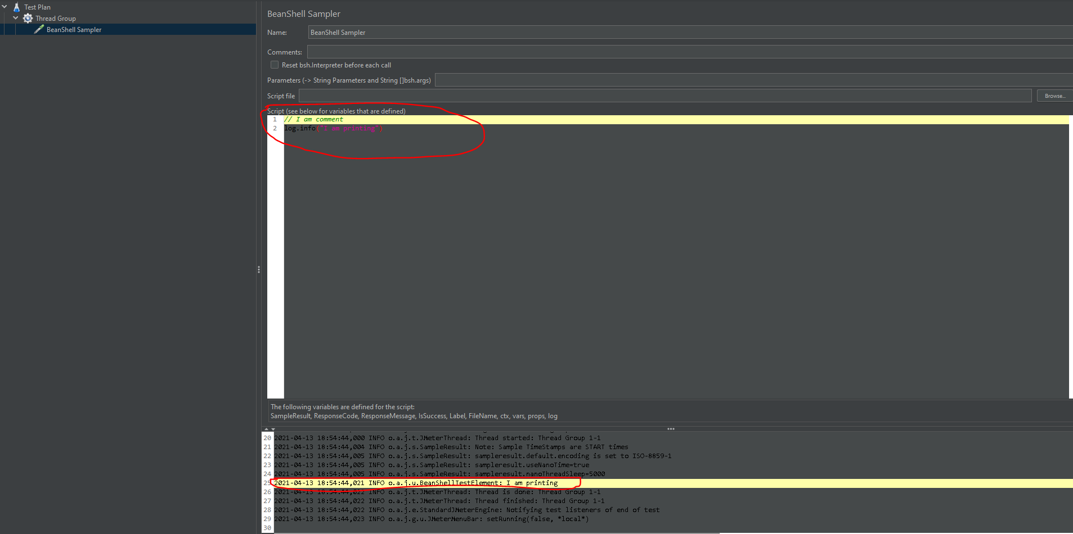

- Like wise we can create scripts and we can get the results over here.

